1 | Principio del formulario  Final del formulario
  What does VLSM allow a network administrator to do?
   | utilize one subnet mask throughout an autonomous system
   | utilize multiple subnet masks in the same IP address space
   | utilize IGRP as the routing protocol in an entire autonomous system
   | utilize multiple routing protocols within an autonomous system
2 | Principio del formulario  Final del formulario
  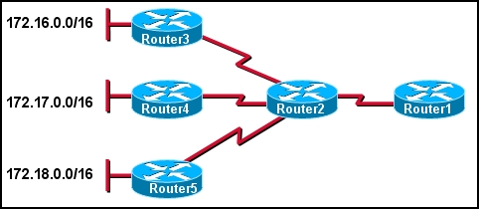
  Refer to the exhibit. The network administrator wants to minimize the number of entries in Router1’s routing table. What should the administrator implement on the network?
  VLSM
  CIDR
  private IP addresses
  classful routing

3 | Principio del formulario  Final del formulario
  What two advantages does CIDR provide to a network? (Choose two.)
   | reduced routing table size
   | dynamic address assignment
   | automatic route redistribution
   | reduced routing update traffic
   | automatic summarization at classful boundaries
4 | Principio del formulario  Final del formulario
  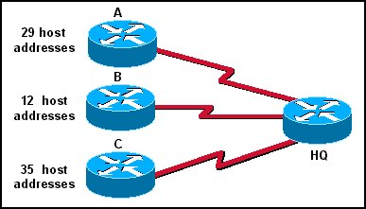
  A Class C address has been assigned for use in the network shown in the graphic. Using VLSM, which bit mask should be used to provide for the number of host addresses required on Router A, while wasting the fewest addresses?
  /31
  /30
  /29
  /28
  /27
  /26

5 | Principio del formulario  Final del formulario
  Which three interior routing protocols support VLSM? (Choose three.)
  OSPF
  RIP v1
  RIP v2
  EIGRP
  BGP
  STP
6 | Principio del formulario  Final del formulario
  
  Refer to the exhibit. The network administrator wants to create a subnet for the point-to-point connection between the two routers. Which subnetwork mask would provide enough addresses for the point-to-point link with the least number of wasted addresses?
  255.255.255.192
  255.255.255.224
  255.255.255.240
  255.255.255.248
  255.255.255.252

7 | Principio del formulario  Final del formulario
  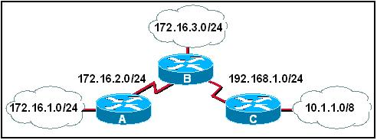
  Refer to the exhibit. What subnet mask will be applied if Router A sends a RIPv1 update for the network 172.16.1.0 to Router B?
  none
  8
  16
  24
8 | Principio del formulario  Final del formulario
  Which of the following problems does VLSM help to alleviate?
  the shortage of IP addresses
  the difficulty of assigning static IP addresses to hosts in large enterprises
  the complexity of implementing advanced routing protocols such as OSPF and EIGRP
  the shortage of network administrators qualified in the use of RIP v1 and IGRP

9 | Principio del formulario  Final del formulario
  Which of the following are contained in the routing updates of classless routing protocols? (Choose two.)
  32-bit address
  next hop router interface
  subnet mask
  unicast host address
  Layer 2 address
10 | Principio del formulario  Final del formulario
  A network administrator is tasked with dividing up a class C network among the QA, Sales, and Administration departments. The QA department is made up of 10 people, the Sales is made up of 28 people, and the Administration has 6. Which two subnets masks adequately address the QA and Sales departments? (Choose two.)
  255.255.255.252 for QA
  255.255.255.224 for Sales
  255.255.255.240 for QA
  255.255.255.248 for QA
  255.255.255.0 for Sales

11 | Principio del formulario  Final del formulario
  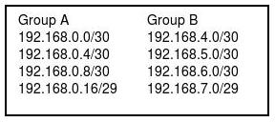
  Refer to the exhibit. A network engineer is summarizing the two groups of routes on router R1 shown in the exhibit. Which summarization will work for all the subnets?
  192.168.0.0/23
  192.168.0.0/22
  192.168.0.0/21
  192.168.0.0/20
12 | Principio del formulario  Final del formulario
  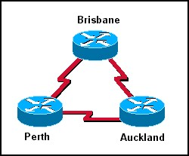
  In the network shown in the graphic, three bits were borrowed from the host portion of a Class C address. How many valid host addresses will be unused on the three point-to-point links combined if VLSM is not used?
  3
  4
  12
  36
  84
  180

13 | Principio del formulario  Final del formulario
  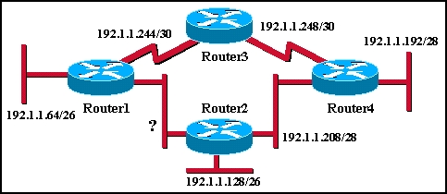
  An additional subnet is required for a new Ethernet link between Router1 and Router2 as shown in the diagram. Which of the following subnet addresses can be configured in this network to provide a maximum of 14 useable addresses for this link while wasting the fewest addresses?
  192.1.1.16/26
  192.1.1.96/28
  192.1.1.160/28
  192.1.1.196/27
  192.1.1.224/28
  192.1.1.240/28
14 | Principio del formulario  Final del formulario
  A router has a summary route to network 192.168.32.0/20 installed in its routing table. What range of networks are summarized by this route?
  192.168.0.0 – 192.168.32.0/24
  192.168.0.0 – 192.168.47.0/24
  192.168.32.0 – 192.168.47.0/24
  192.168.32.0 – 192.168.48.0/24
  192.168.32.0 – 192.168.63.0/24

